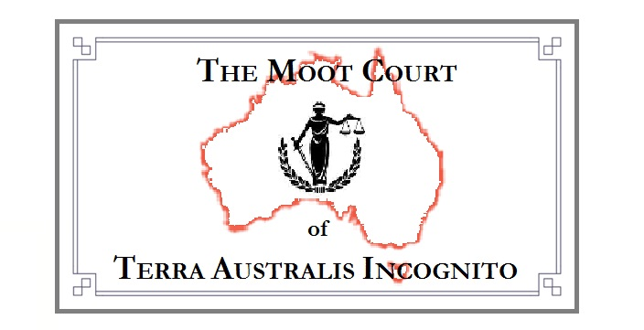
Form of General Non-enduring Power of Attorney

This general non-enduring power of attorney is made under the unalienable laws and rights of living men and woman, and the law of the land of Terra Australis, which is reflected in Part 2 of the “Powers of Attorney Act 2014” and has effect as a deed, and

This general non-enduring power of attorney is made on the ________________ 2022, and

I, ‘the living man ‘John Robert’, of the family Smith

(also known as “John Robert Smith”)

of street address, the town known as “Suburb”, on the land known as Terra Australis “[State Postcode]”

appoint the living woman ‘Mary Jane’, of the family Jones

of street address, the town known as “Warragul”, on the land known as Terra Australis “[State Postcode]”

to be my Attorney in Fact, and to speak and do on my behalf anything that I may lawfully authorise an attorney to do in regards to my interactions with “CitiPower Pty Ltd”, “ABN 76 064 651 056”, “Powercor Australia Ltd”, “ABN 89 064 651 109”, and, “United Energy”, “ABN 70 064 651 029”, and/or any of its agents, and

I specify that this power of attorney begins immediately on this date, _______________ 2022.

Autographed as a deed by

The living woman ‘John Robert’,
of the family Smith

Witness 1.

I, the living woman ‘Fred Ian’, of the family Brown
of 14 First Street in the town known as “Melbourne”, on the land known as Terra Australis

and

I, the living woman ‘Betty Lou’, of the family White
of 22 Second Street in the town known as “Melbourne”, on the land known as Terra Australis

certify that the principal, the living woman ‘John Robert’, of the family Smith:

a) voluntarily autographed this Power of Attorney in my presence; and
b) at the time the principal autographed this Power of Attorney, the principal did so with what I believed was a clear understanding of the nature and effect of the instrument.

Witness 1.

Autograph ……………………………..

Date known as ……………………………..

Witness 2.

Autograph ……………………………..

Date known as ……………………………..

I, ‘Mary Jane’, of the family Jones, agree to act, with integrity and honesty, as Attorney in Fact for the living woman ‘John Robert’, of the family Smith

Autographed as a deed by

The living woman ‘Mary Jane’, of the family Jones

Witness 1.

Autograph ……………………………..

Date known as ……………………………..

Witness 2.

Autograph ……………………………..

Date known as ……………………………..

